**3. Queue design**

I. Queue Structure & Priority Handling

* 3 priority levels will be used: High (urgent), Medium, Low.
* Jobs are pushed with metadata: job_id, type, priority, payload, retry_count etc.
* Workers then fetches the tasks in priority order: 1-5. With 1 being the highest priority.
* Within the same priority, jobs are processed FIFO (first-in, first-out).
* The job either succeeds or fails and moves to retry logic

II. Retry Policy

In case a task is not able to be completed; the system will retry.

* Retry count is defined by the system user (e.g., 3 times, 10 times etc)
* After each failure, job is requeued (with incremented retry_count after each retry)
* A backoff time/ wait period between retries is added. (which could also be configured)
* The retry logic ensures that workers don’t get stuck on failing jobs, allowing other jobs to continue processing.

III. Dead Letter Queue (DLQ)

* Each main queue has a DLQ to store jobs that have exceeded their max retries.
* DLQ helps investigate failures without blocking main queue
* It helps in monitoring, debugging, or manual reprocessing.
* Optional alerting can be added to notify administrators when jobs enter the DLQ.

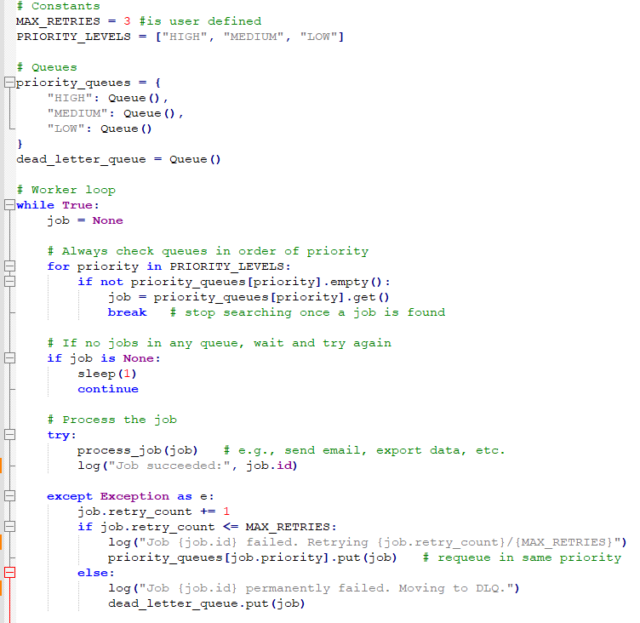

Figure Pseudocode for Queue design